T2 Q2 Now What?
After watching the videos in Thing 2 Quest 2, you will create a visual organizer. You will put in the steps you learned to solve the problems. Use the example below to help you create your evidence.
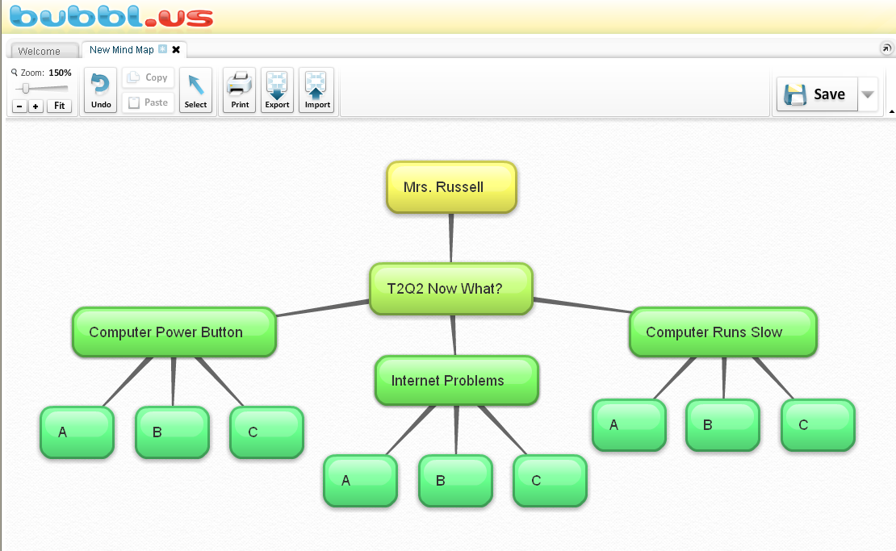
Your name goes here

